Hanover & Elm Grove Communities Forum
Meeting notes January 2022
Present: Sarah (Chair), Ian Mac (Hanover Action), Vanessa (LNEHRA), Chris & Bonnie (Sussex Police), Anne Krause (City Fibre), Nick Wells, Amanda (Pankhurst Pantry), Chloe (Phoenix Artspace), Sarah F, Yasmin, Cllr Elaine, Simon (BHCC), Mark (TDC) Alexia (Hanover Community Association)
- Happy new year and ambitions for the year ahead:
  - Develop the Community Council initiative
  - Welcome the new groups in Elm Grove and encourage groups in other under represented parts of the ward.
  - Get the Liveable Hanover & Tarner project going
  - Look for funds for the LNEHR group
- Police update
Both the Hanover Twitten and the Wellington Rd estate have been much quieter.
Q: Are there proactive drugs workers/projects in the area still
A: Yes there is an organisation called CGL which works with St Mungo’s in the city.
Q: In Cobden Road there is an issue with lorries driving the wrong way on the one-way street. Can anything be done?
A: This can be reported to http://www.operationcrackdown.org/ which will lead to action being taken. This is also something to raise with councillors.
- City Fibre
Anne Krause gave a presentation on the City Fibre work programme. This is a project to provide high speed fibre optics across the area which will increase our broadband capacity. Residents will have choice of broadband providers able to use the network. Putting it in place involved a fair bit of digging, although City Fibre are making use of existing infrastructure where possible.
Contact for further info: anne.krausse@cityfibre.com
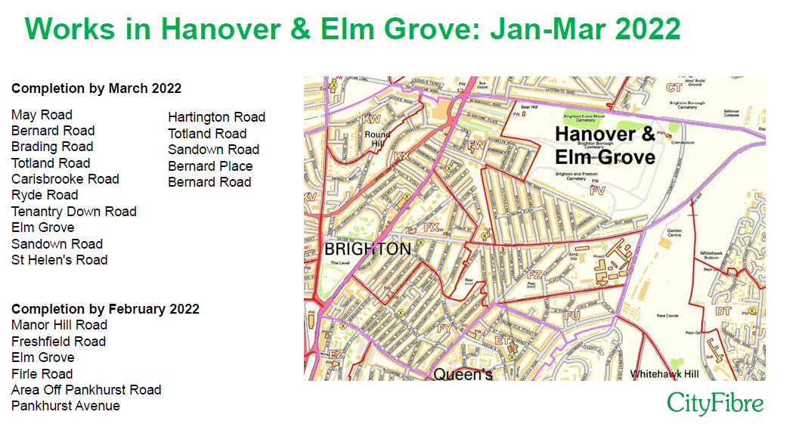

Q: What are the hours of work
A: The hours of work are covered by street works guidelines and shouldn’t include antisocial hours
Q: How are people being informed?
A: They would normally doorknock, but because of Covid are now doing a letter drop 1 week before works commence
- Gladstone Court update
The final community panel which met before Christmas agreed to rename Gladstone Court for Manoj Natha-Hansen, an inclusion worker at the adjacent school who sadly died in 2020. Manoj was well respected in the community and supported children from marginalised backgrounds in their education.
The final name choice will be Manoj House and their will be a naming event attended by family members when such events are easier to arrange.
- Councillors ward budget
Each year our councillors have a ward budget of £1000 each to support local projects and activities. Our councillors are currently looking for suggestions for this years fund and would welcome ideas.
Q: How will it be decided? Last year projects put in work on a bid but were turned down and they should have known more about the process
A: It is quite hard to completely suit everyone, but we will try our best to be clear and to get a consensus around projects.
Q: TDC have a good model for deciding small grants – could we use that?
- Liveable Hanover & Tarner
The engagement process is now complete and the consultants will be providing options later this month for discussion, and these will form the basis of the final proposal for the pilot scheme which will be consulted on and hopefully implemented later in the year.
- Elm Grove Matters
The Lower North East Hanover Residents Group was inspired by the Liveable Hanover campaign to start working in its area for local neighbourhood improvements. The have put a petition and deputation to the council to request support for this.
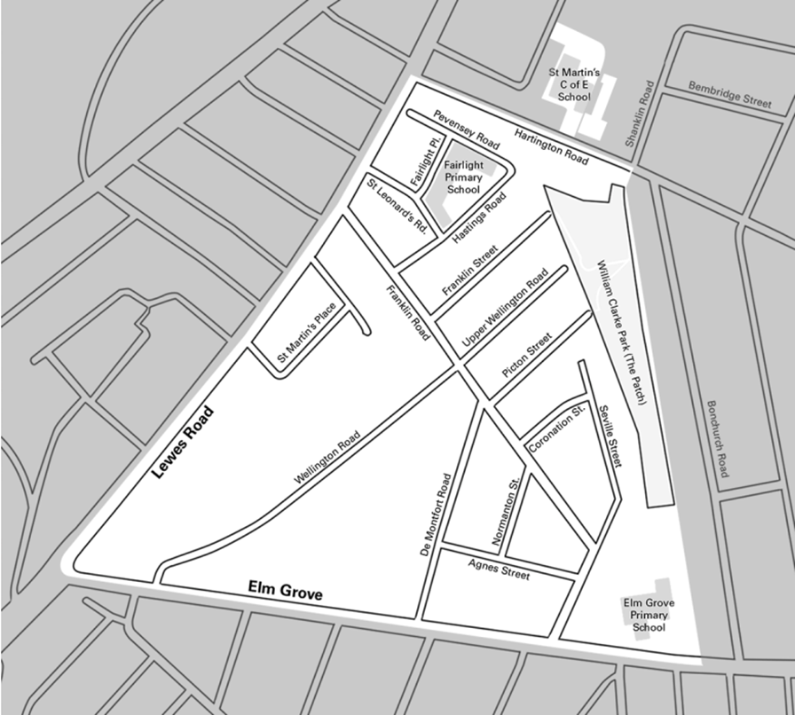

- Food projects
Amanda from the Pankhurst Pantry gave an update on their work:
- The group has moved away from the foodbank model and has become a “pay as you feel” community food shop
- They have separated from Brightstore and are once more an independent group
- The serve 40/50 households each week
- Fundraising is always a challenge, but they have funds to operate this year.
Sarah updated on the Phoenix project:
- A key volunteer has stepped down leading to short term issues, but this is being managed
- The project is moving to a shop model where people select their own produce rather than having a bag prepared for them
- They have strong local partnerships with Phoenix & Albion Life, and would like to develop closer links with the Pankhurst Pantry.
- AOB
- Cllr Elaine was interested in local PPE recycle facilities and would like to put this on the next agenda
- The next exhibition at the Phoenix Artspace will be ‘Murmuration’s’, a piece of work focussing on the starlings at the pier.
- Bank Account – going for the Co-op. Dinah & Simon to get together on this

- Next meeting dates
10th Feb.

